HUIZHOU JIEMEISI TECHNOLOGY CO., LTD.

Messrs. Date : 25th June, 2024
LLC «DEFENDER COMPANY»

Item Conformity

We hereby certify that the below mentioned item was produced for
China Electronics ShenZhen Company which is equal to Defender model, the change does not affect the CE conformity.

Supplier’s item # | Defender Product name | Article #
X11 | Beatbox 16 | 65216

Defender model series are corresponded to supplier’s items as shown
on the reports and certificates, applied by HUIZHOU JIEMEISI TECHNOLOGY CO., LTD.

Provided and confirmed by :
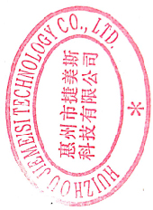
HUIZHOU JIEMEISI TECHNOLOGY CO., LTD.

Jumping
----------------------------------------------------------------
Sales Manager

